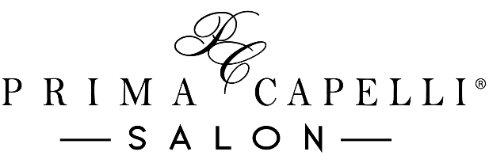

In Salon Bridal Services Contract

Security Deposit

~ A security deposit is required to guarantee the requested wedding date
~ A $300 deposit is required for 2 or more bridal guests
~ The deposit will be applied to the cost of services the day of the wedding
~ Deposits are refundable up to six weeks prior to the wedding
~ The contract must be signed and the security deposit must be submitted within one week of booking the services to secure the requested date

____ (Initial Here)

Cancellation

~ Appointments are subject to cancellation if deposit and contract are not submitted within one week of booking services
~ Cancellations or modifications to wedding-day appointments must be made no later than six weeks prior to the requested wedding date
~ Failure to cancel the bridal party after the deadline of the six-week time frame will result in the forfeiture of all of the security deposit. The base price of any individual service canceled after the 6-week deadline will be deducted from the deposit
____ (Initial Here)

Miscellaneous

~ To ensure satisfaction of services for the day of the wedding, we recommend the bride schedule a practice formal style and makeup trial prior to the wedding day. In salon pricing will apply for this appointment. Pricing for the trial services is separate from the deposit and wedding day costs
~ We recommend all guest receiving formal styles wash their hair 1 day before the wedding (In order for our stylists to achieve the best results hair should neither be too clean nor too dirty)
~ Additional charges may apply to any bridal party guest who arrives with wet hair; we cannot guarantee timely completion of services if guests arrive with wet hair
~ Please wear a shirt that is easy to remove and won’t ruin your style, such as a button-down top

____ (Initial Here)

Pricing
Pricing of styles may vary or exceed the quoted limit depending on length and/or thickness of hair, time involved, and/or intricacy of the style

~ Formal Up Style…. $75-$100

~ Formal Down Style…. $40-$55

~ Formal Blow-Dry Style…. $35-$45

~ Children’s Formal Style…. $45-$50

~ Partial Make-up Application…. $40 and up

~ Full Make-up Application…. $65 and up

~ Eyelash Application…. $15

A 20% gratuity charge will be added to all services completed

**In addition to this contract, a final contract must be signed at the 6-week prior to the wedding day. This will include the exact number of services requested. The base cost of each contracted service NOT performed the day of the wedding will be deducted from the security deposit**

Submission Details

Wedding Date: ________________ Desired time of completion: ______________

Number of Hair Services Requested: ______________

Number of Makeup Services Requested: ___________

Signature: ___________________________________ Date: ________________

Your special day is just as important to us as it is to you. We will provide you with professional, punctual service to ensure your day is magical and memorable.
Thank you for choosing Prima Capelli Salon.
Contract prices are valid through December 31st, 2024

