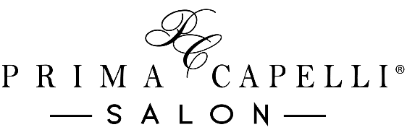

In Salon Bridal Services Contract For One Person

Security Deposit
~ A security deposit is required to guarantee the requested wedding date
~ A $75 deposit is required for 1 bridal guest
~ All deposits will be applied to the cost of services the day of the wedding
~ Deposits are refundable up to six weeks prior to the wedding
~ The contract must be signed and the security deposit must be submitted within one week of booking the services to secure the requested date

____ (Initial Here)

Cancellation
~ Appointments are subject to cancellation if deposit and contract are not submitted within one week of booking the services
~ Cancellations or modifications to wedding-day appointments must be made no later than six weeks prior to the requested wedding date
~ Failure to cancel the individual service requested before the six-week time frame will result in the forfeiture of all or part of the security deposit

____ (Initial Here)

Miscellaneous
~ To ensure satisfaction of services for the day of the wedding, we recommend the bride schedule a practice formal style and makeup trial prior to the wedding day. In salon pricing will apply for this appointment. Pricing for the trial services is separate from the deposit and wedding day costs
~ We recommend all guest receiving formal styles wash their hair the day before the wedding, not the day of, as clean hair does not hold up as well as second day hair
~ Additional charges may apply to any bridal party guest who arrives with wet hair; we cannot guarantee timely completion of services if guests arrive with wet hair
~ Please wear a shirt that is easy to remove and won’t ruin your style, such as a button-down top

____ (Initial Here)

Pricing
**Pricing of styles may vary or exceed the quoted limit depending on length and/or thickness of hair, time involved, and/or intricacy of the style**

~ Formal Up Style…. $75-$100

~Formal Down Style…. $40-$55

~ Formal Blow-Dry Style…. $35-$45

~ Children’s Formal Style…. $45-$50

~ Partial Make-up Application…. $30 and up

~ Full Make-up Application…. $55 and up

~ Add on False Lashes…. $15

A 20% gratuity charge will be added to all services completed.

**In addition to this contract, a finalized contract must be signed at the 6-week mark including the exact number of services requested. The base cost of each contracted service not performed the day of the wedding will be deducted from the security deposit**

Wedding Date: ________________ Time of Ceremony: ______________

Number of Hair Services Requested: ______________

Number of Makeup Services Requested: ___________

Bride Signature: ___________________________________ Date: ________________

Bridal Coordinator: _________________________________Date: ________________

Your special day is just as important to us as it is to you. We will provide you with professional, punctual service to ensure your day is magical and memorable.
Thank you for choosing Prima Capelli Salon.
*Contract prices are valid through December 31st, 2024*

